Table of Contents
Table of Contents 1
A Word from our Pastor and Administrator 2
Associations and Achievements 3
Parent/ Teacher Communication 4
Orientation Meetings 4
Online Communication 4
Parent/Teacher Conferences 4
The Value of Private Education 5
Tuition and Fees 6
Tuition 6
Fees 6
Discounts 6
Application for Enrollment 7
Medical Release 9
Records Request 10
Pick-up Permission Form 11
Photography/Video Agreement 11
BINDING ARBITRATION AGREEMENT 12
Admission 13
Admissions Checklist

❑ Application / Registration Card
❑ Emergency Information
❑ Medical Form
❑ Financial Agreement
❑ Advance Fees

A Word from our Pastor and Administrator

One of the best decisions I made after coming to FBT was to follow the Lord’s direction in reopening Temple Christian Academy. Every week after my arrival, someone would ask me about the future of the school. After much prayer and counsel the doors to TCA were opened again in the fall of 2007 with 13 students. Since that time we have grown up into the forties and before 2012 finishes we will have graduated four students and impacted several others.
My goal for our Christian School is to influence a generation of young people for the cause of Christ. We want them to be fully prepared to impact their culture while attending college, providing for and raising a family, and serving in a local church. We emphasize academic preparedness along with spiritual awareness by challenging the gifted and strengthening those who struggle.
Each year we have seen God improve and enable our ministry to better serve Him and families like yours. New students and a growing staff have provided an upward momentum for our school while we have sadly seen other schools throughout our nation struggle in this economy. We are certainly grateful for God’s blessings and the growing confidence parents have placed in TCA. All indicators predict that we will continue to grow in the coming years. However, we want you to know that we will continue to emphasize individual attention to each of our students.
The Click Family
Micah, Zach, Garrison
Nanette, Gary
Among our recent additions, we were very happy to welcome Mr. Rick Ash as our new administrator. He has done an excellent job during his first year at TCA, and we have great confidence that the school will continue to grow and improve each year, providing an excellent education in a Christian atmosphere.

The choice of where to enroll your student is a very important and sometimes difficult decision. You want your student to receive the best possible education. But does that mean going to a public or private school? Is a private or Christian school worth the sacrifice financially? Is Christian education really that important anyways?
A Christian education is vital for our young people. The Bible says in Proverbs 1:7, “The fear of the Lord is the beginning of knowledge…” The true beginning of education is an understanding of the order that God has placed in our world. From this brings an understanding of the laws of science, math, and even language.
I am a product of Christian education. I went to Christian school from preschool through college graduation. I personally received the benefits of being challenged with the high academic standards of a private school while learning to view life through a biblical worldview. Now as an educator, I carry the passion to impart the same thing to all of my students.
My goal for each of our students is for them to leave our school with the ability to be godly, functioning members of society. I want them to be fully equipped for the direction that God has for their lives. This means that our school will prepare them academically. We will teach them about character and godly lifestyles. They will learn the benefits of diligence and hard work.
The Ash Family
Brendyn, Thomas
Bethany, Rick,
Megan
I hope that we have the opportunity to partner with you in the education of your student. Please know that we will be praying with you as you make this important decision.

Associations and Achievements

Temple Christian Academy is a member of the Buckeye Christian School Association (BCSA) and the American Association of Christian Schools (AACS). Pastor Click serves on the board of directors for BCSA and acts as their legislative director in Washington.

TCA & BCSA schools consistently outperform the national averages!

 | Nat . Avg. | BCSA | TCA
K | 0.8 | 1.4 | 1.3
1st | 1.8 | 2.4 | 2.3
2nd | 1.8 | 3 | 3.6
3rd | 2.8 | 5.6 | 4.3
4th | 4.8 | 6.1 | NA
5th | 5.8 | 8 | 7.7
6th | 6.8 | 8.5 | 7.6
7th | 7.8 | 9.4 | NA
8th | 8.8 | 10.9 | 12.8
9th | 9.8 | 13 | 10.5
10th | 10.8 | 13 | 13

*Data not available for all classes.

Parent/ Teacher Communication
We view Christian education as a team effort. The value of education begins at home. Involved and informed parents are an essential element of a well-educated student. The Christian school is a resource for parents that facilitates the learning process. Just as a dentist helps with your child’s dental needs and a physician their physical needs, the teacher helps with your child’s educational needs. Just as parents and medical practitioners communicate concerning a child’s physical health, we believe that parents and teachers share an obligation to communicate concerning your child’s educational health.
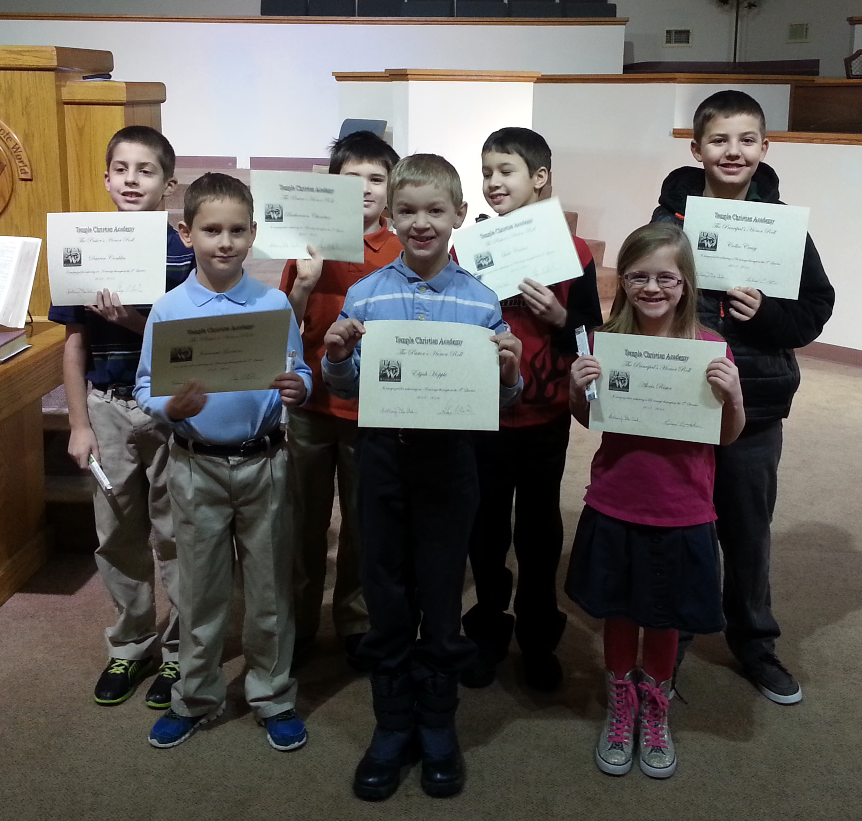
Our Annual Awards Ceremony recognizes student achievement.

Orientation Meetings
Each year begins with a Parent/Teacher/Student orientation. This is the first contact of the year after enrolling your children in TCA. You will meet teachers and learn of changes, policies, opportunities and expectations. This is the perfect time to get acquainted with your child’s learning environment as well as meet other parents and students of TCA. Attending the orientation is the first step in establishing good communications with your student’s teachers.

Online Communication
Advancing technology has made communications more effective and efficient. Did you have a question that arose in the middle of the night or perhaps during the school day when the teacher is unavailable? Email is the answer. Just shoot a quick email to the teacher and they can respond the next school day.
Our online grading system allows you to check on your student’s progress any day of the week at any time of the day. Email alerts may notify you immediately whenever your child falls below an expected standard.
Has your child ever failed to bring the school newsletter or a note from the teacher home? Online bulletin boards are always accessible and don’t get lost at the bottom of the backpack or in the backseat of the car. The school calendar is posted online and updated regularly for your convenience.

Parent/Teacher Conferences
Parent/Teacher conferences are scheduled with each family to insure proper communication and awareness. However, teachers are available after school to answer any general questions and special conferences can be set up at any time to discuss your child’s personal needs.

The Value of Private Education
Did you know that 11% of all students (6,049,00) attend a private school? Of that amount, the majority attend Catholic Schools. Conservative Christian and Baptist schools combined would rate second at 20.7%, according to the National Center for Education Statistics.

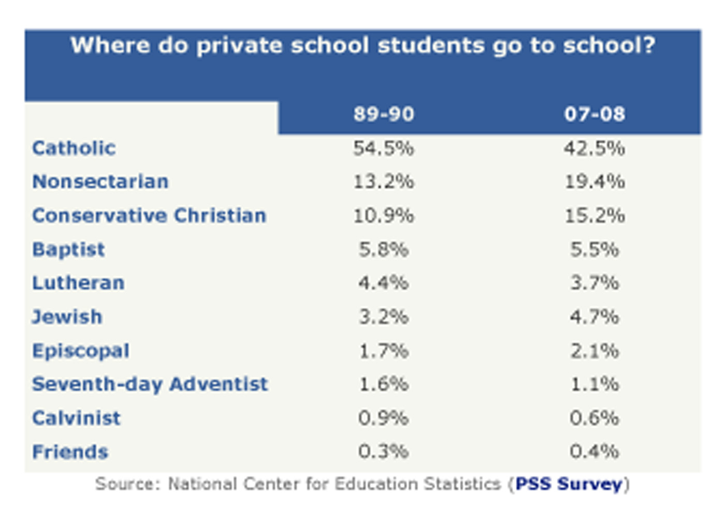
What is a Christian education worth? The average family pays anywhere from just under $5,000 to over $10,000 to place their children in a Christian school and over $27,000 in some secular schools.

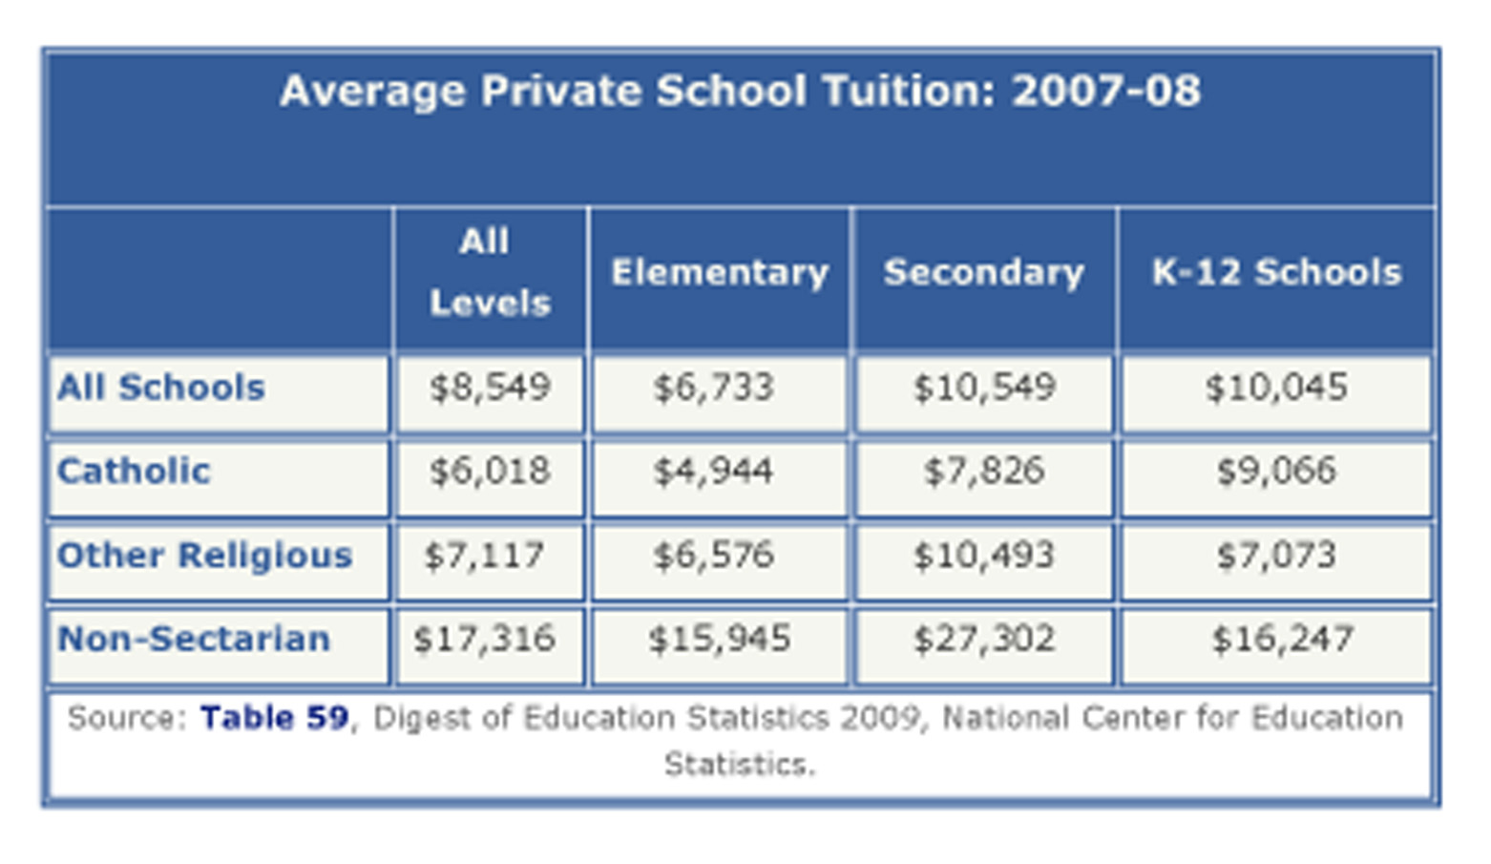
How much is Christian education worth to you?

Tuition and Fees
This is one area in which we are proud to be well below average! In fact, our tuition is less than half of the lowest national average. We desire for Christian education to be affordable. Our church, the Fremont Baptist Temple, provides resources that permit us to offer a private, Christian education at a price you can afford. Our teachers serve as missionaries in Christian education, accepting salaries far below the average because they care about making a difference for today’s families.

Tuition
Child | Annual Tuition | Monthly Payment
1st | $2,400 | $200.00
2nd | 2,300 | 191.67
3rd | 2,200 | 183.33
4th | 0 | 0
5th | 0 | 0

Fees
Registration Fee | Books/Materials | Technology Fee
$100 | $350 | $15 per month

Discounts
Full Year Paid in Advance | Each Semester Paid in Advance | Faithful Members of Fremont Baptist Temple | Automatic Withdrawal through FACTS | Scholarship Opportunities
10% | 5% | 10% | $50 per student enrolled*  *only the 1st three students in a family are eligible since the others are not charged tuition | Special offers may be available for those in need depending on funding. Ask for details.

First month’s tuition and fees are due by August 1st. Payments on the 12 month plan end on July 1st.

Application for Enrollment
Student Information Date:_______/________/______
First Middle Last
Enrollment Year Age DOB Grade at time of enrollment
Cell Phone Home Phone
^{Email Address}
Street Address City State Zip
Father’s Information’s
First Middle Last
Cell Phone text y/n Home Phone
^{Email Address}
Street Address City State Zip
^{Employer}
Mother’s Information
First Middle Last
Cell Phone text y/n Home Phone
^{Email Address}
Street Address City State Zip
^{Employer}
Previous Schools Attended
^{School Name}
Grades Attended Start Date End Date
Address City State Zip
Phone Fax
^{Website}
Previous Schools Attended
^{School Name}
Grades Attended Start Date End Date
Address City State Zip
Phone Fax
^{Website}
Previous Schools Attended
^{School Name}
Grades Attended Start Date End Date
Address City State Zip
Phone Fax
^{Website}

Home Church Information
Although church attendance is strongly encouraged, it is not required to enroll in TCA.
^{Church Name}
Address City State Zip
Pastors Name Church Phone
^{Pastor’s Email}
How long have you attended? How frequently do you attend?

Has this student ever been expelled or suspended from school? Yes No If so, please explain.

Has this student ever been arrested for a misdemeanor or felony? Yes No If so, please explain.

How did you hear about TCA? Phonebook Billboard  Newspaper  Church Friend  Mailing
❑ Student _____________________________  Other____________________________________

❑ I intend to communicate clearly with my student’s teachers and the administration concerning
my student’s grades and behavior.

❑ I understand that it is a privilege, not a right, to attend Temple Christian Academy. With this in mind, students must conduct themselves in a manner becoming a Christian at all times.

❑ I understand that all new students are admitted on probation for the first nine weeks.

❑ I understand that the Lord Jesus Christ expects us to be disciplined in all areas of life.

❑ I have read the Student Handbook paying special attention to all bold typed changes from any previous handbooks.

❑ I understand the rules and policies in the Handbook and as a parent and give Temple Christian Academy faculty permission to carry out any disciplinary action in the afore mentioned handbook they deem necessary for my student.

❑ I will work cooperatively with the school whenever disciplinary procedures are deemed necessary.

❑ I will pay my tuition and fees in a timely manner and will communicate with the administration if there is any reason for delay in my payments.

________________________________________________________________________________
^{Name} ^{Relationship} ^{Date}
________________________________________________________________________________
^{Name} ^{Relationship} ^{Date}

Medical Release
I give permission for TEMPLE CHRISTIAN ACADEMY to seek appropriate medical care for my child in the case I cannot be reached. This includes calling 911 or taking them to the hospital if necessary.

Should an emergency arise, it is understood that a conscientious effort will be made to locate, in order; all persons listed as emergency contacts on the registration form, before emergency action is taken.

I agree to provide a copy of my child’s shot records to TCA.

I agree that any expenses of emergency treatment, care and transportation are my financial responsibility.

Medical Information
Student Name Age

Personal Physician Phone

^{Allergies}

^{Insurance Provider}

^{Policy Number}

Emergency Numbers
Emergency Number 1 Name Father

Emergency Number 2 Name Mother

Emergency Number 3 Name Home

Emergency Number 4 Name Relationship

Emergency Number 5 Name Relationship

Emergency Number 6 Name Relationship

Emergency Number 7 Name Relationship

Emergency Number 8 Name Relationship

Comments:

___________________________________________________________________
^{Signature of Parent/Guardian} ^{Date}

Records Request

Attention Records Department

______________________________________________________________Fax ________________
^{School Name}

I ________________________________________ grant permission for you to release the all records for the student listed below to Temple Christian Academy, Fremont, Ohio. Please be sure to include at all of the following as applicable.

_____permanent record (educational) _____special service data
_____standardized test scores _____psychological tests
_____health _____all personally
Identifiable Data
_____attendance _____other (specify)

________________________________________________________________________________
^{Student} ^{Dates Attended}
________________________________________________________________________________
Authorizing Signature Relationship Date
________________________________________________________________________________
Address City State Zip

FOR OFFICE USE ONLY

Date data released __________________________ by________________________
Date data released___________________________ by_______________________

Please send this information to: Temple Christian Academy
PO Box 865
Fremont, Ohio 43420

Additional Comments:

Pick-up Permission Form

Please note: Only those persons listed on this form are granted permission to pick-up your student from Temple Christian Academy. Any alterations for this list must be made, dated and initialed by the Parent/Guardian.

The persons listed below have my permission to pick-up my student from Temple Christian Academy.

___________________________________________________________________
^{Signature of Parent/Guardian} ^{Date}

Name Relationship Phone

Name Relationship Phone

Name Relationship Phone

Name Relationship Phone

Name Relationship Phone

Photography/Video Agreement

I understand that a photographer or videographer from Temple Christian Academy or Buckeye Christian School Organization (BCSO) may take a picture with my student (listed below) in it, either individually or in a group.

I further understand that these pictures, whether in print or online, may be used in future brochures, videos, or other publications of Temple Christian Academy or its affiliate corporations.

_________________________________
^{Students Name}

____________________________________________________________________
^{Signature of Parent/Guardian} ^{Date}

Binding Arbitration Agreement

SECTION 1 - SUBMISSION TO ARBITRATION
Believing that lawsuits between believers are prohibited by Scripture, all who place their children in the Temple Christian Academy agree to submit to binding arbitration any matters which cannot otherwise be resolved, and expressly waive any and all rights in law and equity to bringing any civil disagreement before a court of law, except that judgment upon the award rendered by the arbitrator may be entered in any court having jurisdiction thereof.

SECTION 2 - NOTICE OF ARBITRATION
In the event of any dispute, claim, question, or disagreement arising out of or relating to this school handbook or other school matter, the parties shall use their best efforts to settle such disputes, claims, questions, or disagreement as befits Christians. To this effect, they shall consult and negotiate with each other in good faith and, recognizing their mutual interests not to disgrace the name of Christ, seek to reach a just and equitable solution. If they do not reach such solution within a period of sixty (60) days, then upon notice by either party to the other, disputes, claims, questions, or differences shall be finally settled by arbitration as described in section 1, above, and such Procedures for Arbitration as are adopted pursuant to Section 3, below.

SECTION 3 - LIMITATIONS ON ARBITRATION DECISIONS
The Procedures for Arbitration shall be as adopted by the school board.

______________________________________________________________________
^{(Date)} (Parent/Legal Guardian or Applicant)

_______________________________________________________________________
^{(Date)} (Parent/Legal Guardian or Applicant)

_______________________________________________________________________
^{(Date)} ^{(Accepted by the Church)}

Admission
All applicants for admission to Temple Christian Academy must obtain an application for admission. Initial acceptance of new students is probationary for the first semester. As a ministry of Fremont Baptist Temple, the school reserves the right to establish and maintain its own standards for student conduct and dress. Students are expected to make acceptable progress both spiritually and academically, to abide by the school rules and guidelines, and to conduct themselves in a manner consistent with the policies and practices as established by the administration. Students who consistently violate the letter and spirit of the rules and guidelines may be asked to withdraw from school. Temple Christian Academy makes no distinction in the admission of students based upon race, gender, nationality, or ethnic culture. As a private Christian institution, admission to Temple Christian Academy is a privilege rather than a right. This privilege may be forfeited and enrollment terminated should a student, new or returning, fail to meet his or her responsibilities as a student at Temple Christian Academy.
By signing these documents, I am stating that I have read and do understand the rules and guidelines set forth in this student handbook. I am willing to follow these guidelines in letter and in spirit.
This document must be signed by students in 7th grade and above.

___________________________________ __________________________________
^{Signature of Parent} ^{Date} ^{Signature of Parent} ^{Date}

___________________________________ __________________________________
^{Signature of Student} ^{Date} ^{Signature of Student} ^{Date}

___________________________________ __________________________________
^{Signature of Student} ^{Date} ^{Signature of Student} ^{Date}

